Fading

The fading effect is based on the simulation method in Rappaport, p.223 and the two rayleigh fading MATLAB files provided by Dr. Wu. The module has five methods: __init__, dopplerSpectrum, genRandomVar, runFourier, and run. The dopplerSpectrum method creates a doppler spread PSD from the formula in Rappaport, p.218. The genRandomVar method creates an array of complex Gaussian distributed values. The runFourier method multiplies the random array with the doppler PSD, then takes the inverse fast Fourier transform to create time domain Rayleigh fading. An example is shown below.

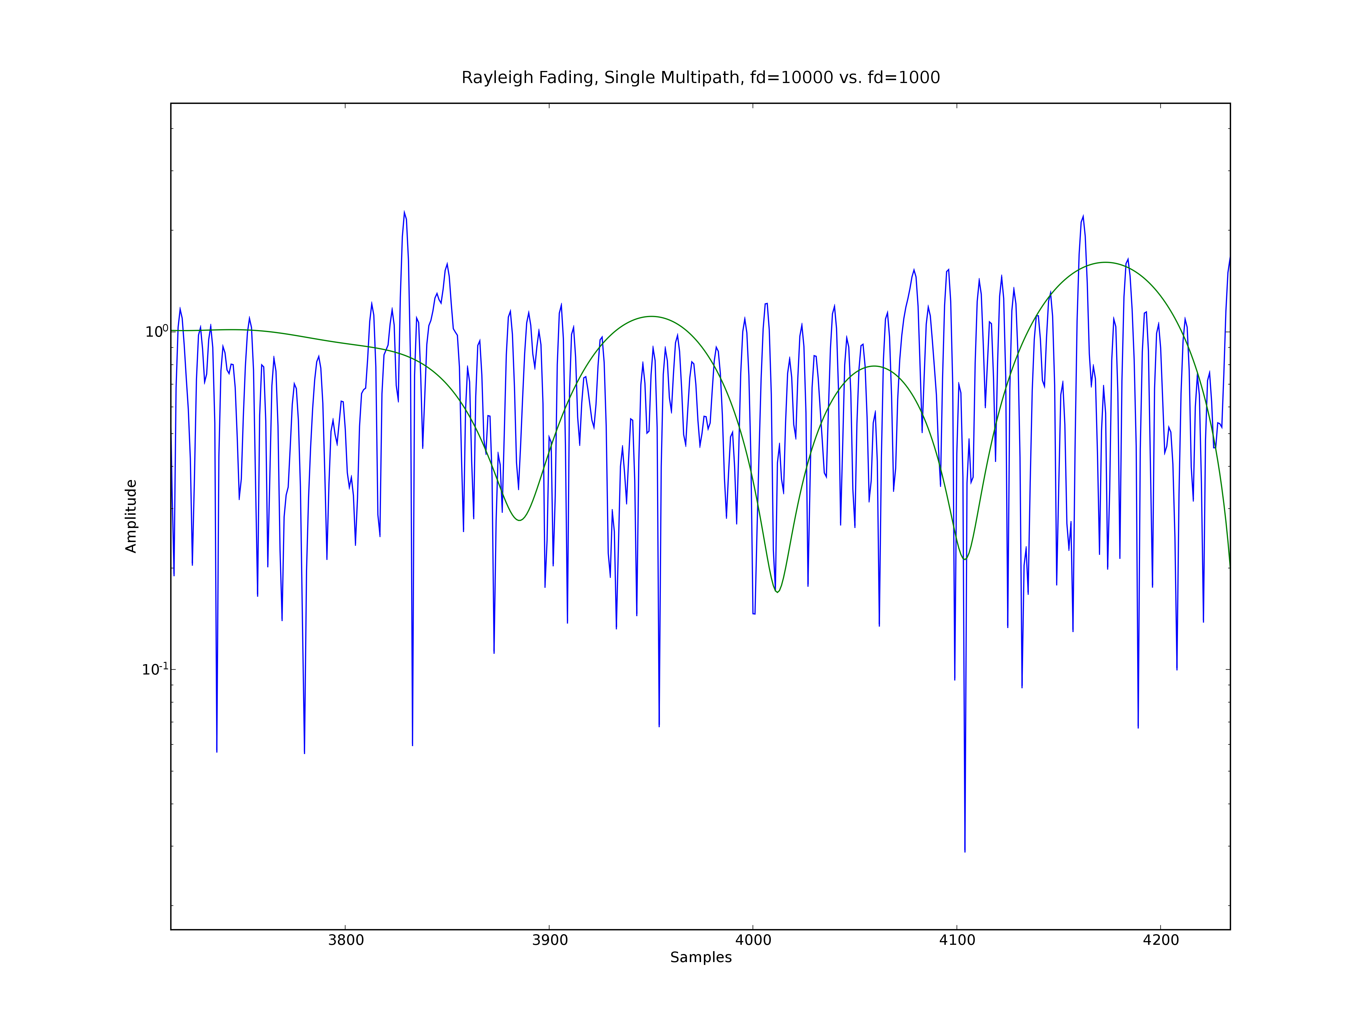Fig 1: Rayleigh fading in the time domain on a semi-log y scale.
To adjust the fading to different channel lengths, power delay profiles, and doppler effects, the __init__ method allows the user to vary the maxdoppler value and the seqlength value. The init method also allows the user to set the period and samples per period of an expected incoming signal (period, samplesperperiod), the samplerate of the Rayleigh fading (samplerate). The maxdoppler value allows the user to generate fast or slow fading, as shown in the figure above. The seqlength value changes two characteristics of the fading: the channel length and the power delay profile. The channel length is set directly by the seqlength value. For a seqlength of 200, period of 1 ms and samplesperperiod of 2000, the channel length is 0.1 ms. The power delay profile is an exponential decay function, and is set at the seqlength/samplesperperiod, with a minimum of 1 path. For example, given a seqlength of 200 and samplesperperiod of 2000, the fading module will generate 1 multipath. For a seqlength of 20000 and samplesperperiod of 2000, the fading module will generate 10 mulipath echoes. An example is shown below.
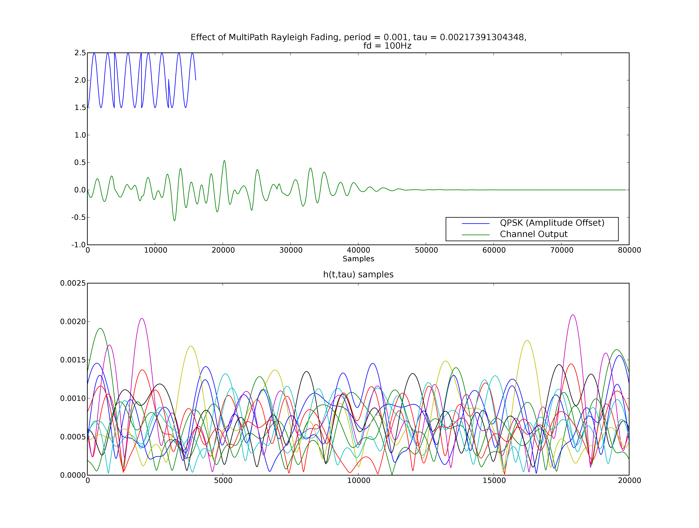Fig 2: Rayleigh fading method with 10 multipath echos.

Usage:

from rayleighfade import *
rfinstance = rayleighfade(period, samplesperperiod, samplerate, maxdoppler, seqlength)
outputarray = rfinstance.run(inputarray)

period: The period of the incoming symbols
samplesperperiod: The number of samples in each of those periods
samplerate: The sampling rate of the generated rayleigh fading.
maxdoppler: The maximum frequency shift due to doppler effects.
seqlength: The length of the PDP decayed to 1%.

